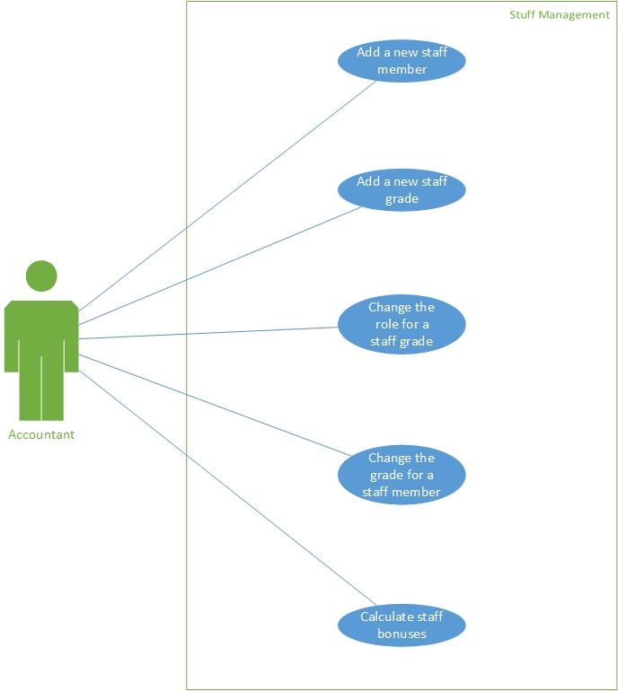

**Figure A2.1** Staff Management use cases.

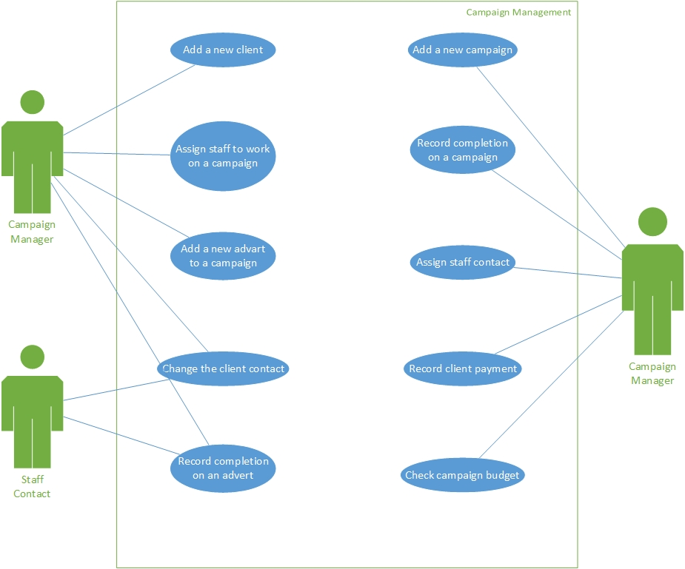

**Figure A2.1** Campaign Management use cases.

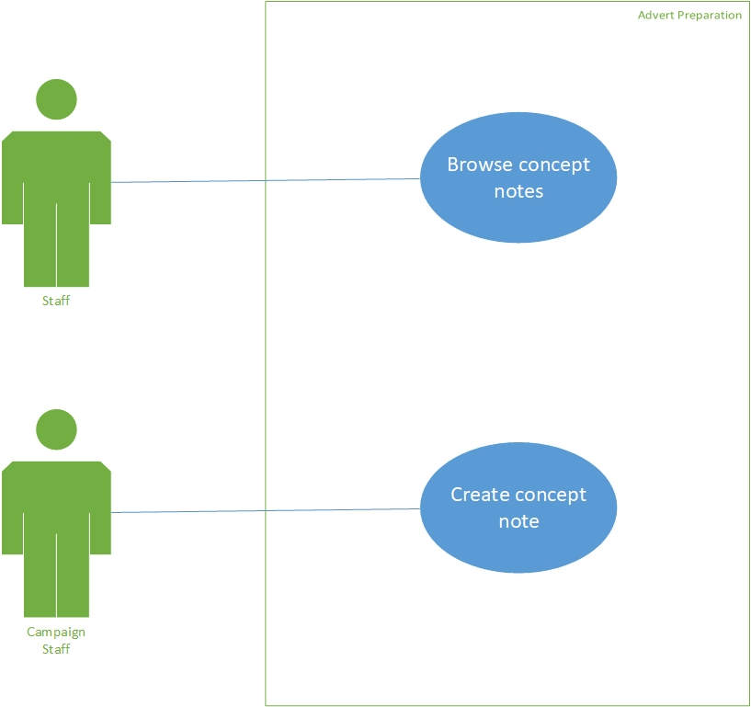

**Figure A2.1** Advert Preparation use cases.

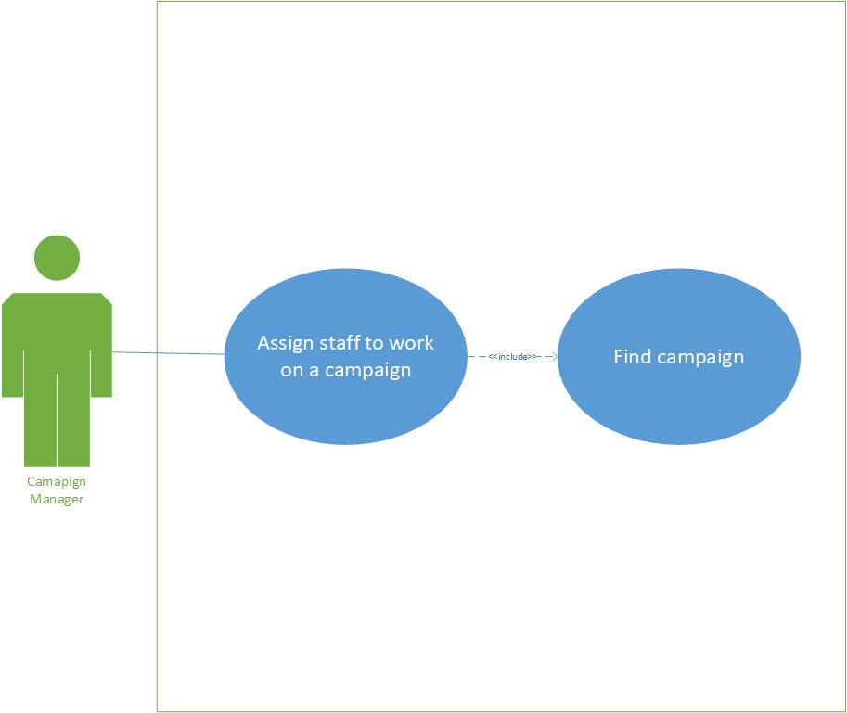

**Figure A2.1** Inclusion of Find campaign use cases.

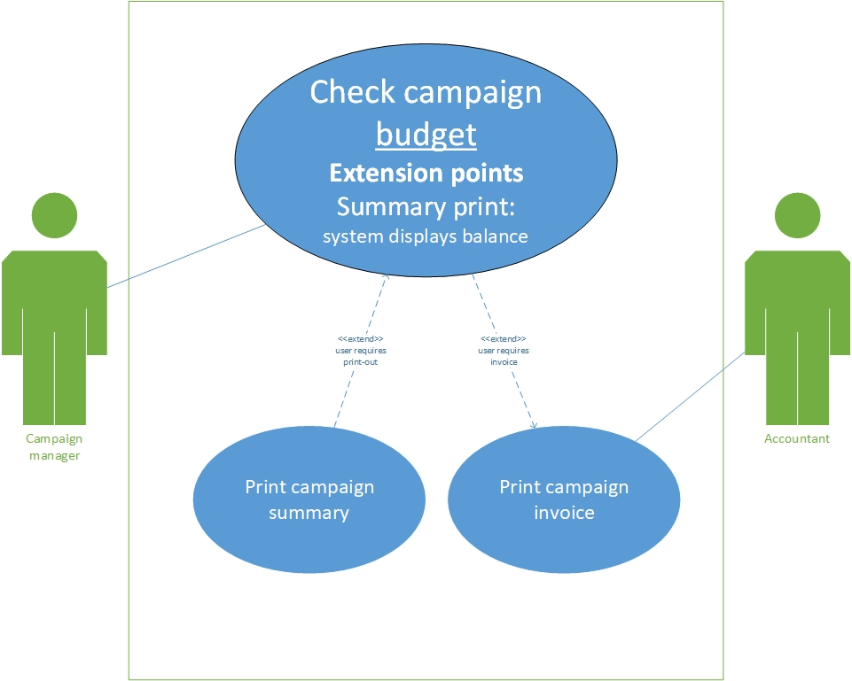

**Figure A2.1** Modified use case Check campaign budget with extensions.